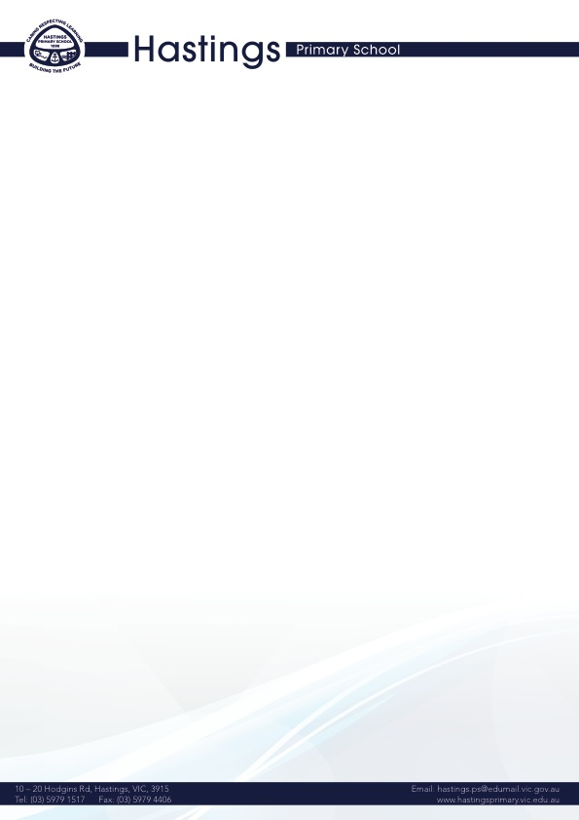**COMMUNICATION WITH SCHOOL STAFF POLICY**

**Help for non-English speakers**

If you need help to understand the information in this policy, please contact Hastings Primary School.

## **Purpose**

This policy explains how Hastings Primary School proposes to manage common enquiries from parents and carers.

## **Scope**

This policy applies to school staff, and all parents and carers in our community.

## **Policy**

Hastings Primary School understands the importance of providing helpful and timely responses to common enquiries from parents and carers. To ensure that members of our school community are directed to the most appropriate person to assist them, the information below outlines key contacts for common queries:

* to report a student absence, please contact the office on (03) 59791517 or [hastings.ps@education.vic.gov.au](mailto:hastings.ps@education.vic.gov.au)
* to report any urgent issues relating to a student on a particular day, please contact the office on (03) 59791517 or [hastings.ps@education.vic.gov.au](mailto:hastings.ps@education.vic.gov.au)
* to discuss a student’s academic progress, health or wellbeing, please contact your classroom teacher.
* for enquiries regarding camps and excursions, please contact the office on (03) 59791517 or [hastings.ps@education.vic.gov.au](mailto:hastings.ps@education.vic.gov.au)
* to make a complaint, please contact the Principal/Assistant Principal on (03) 59791517 or [hastings.ps@education.vic.gov.au](mailto:hastings.ps@education.vic.gov.au)
* Please also refer to our Complaints policy, available on our website, <https://hastingsprimary.vic.edu.au/>
* to report a potential hazard or incident on the school site, please contact Principal/Assistant Principal on (03) 59791517 or [hastings.ps@education.vic.gov.au](mailto:hastings.ps@education.vic.gov.au)
* for parent payments, please contact the office on (03) 59791517 or [hastings.ps@education.vic.gov.au](mailto:hastings.ps@education.vic.gov.au)
* for all other enquiries, please contact our Office on the office on (03) 59791517 or [hastings.ps@education.vic.gov.au](mailto:hastings.ps@education.vic.gov.au)

School staff will do our best to respond to general queries as soon as possible and ask that you allow us 2 – 3 working days to provide you with a detailed response. We will endeavour to respond to urgent matters within 24 hours where possible.

## **Review Cycle**

|  |  |
| --- | --- |
| Policy last reviewed | March 2023 |
| Approved by | Principal |
| Next scheduled review date | March 2027 |